Chapter 12: Multiple Access

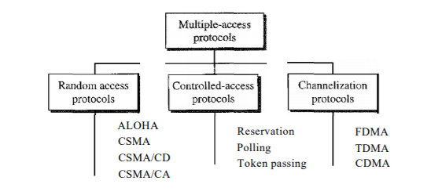

**Question 1. Define random access and list three protocols in this category.**

* In random access or contention methods, no station is superior to another station and none is assigned the control over another. No station permits, or does not permit, another station to send.
* In a random-access method, each station has the right to the medium without being controlled by any other station. There is no scheduled time for a station to transmit. Transmission is random among the stations. That is why these methods are called random access.
* Also, no rules specify which station should send next. Stations compete with one another to access the medium. That is why these methods are also called contention methods.
* Protocols in this category:
* ALOHA
* CSMA
* CSMA/CD
* CSMA/CA.

**Question 2. Define channelization and list three protocols in this category.**

* Channelization is a multiple-access method in which the available bandwidth of a link is shared in time, frequency, or through code, between different stations.
* Protocols in this category:
* FDMA
* TDMA
* CDMA.

**Question 3. Explain why collision is an issue in a random-access protocol but not in controlled access or channelizing protocols.**

In random access methods, there is no access control (as there is in controlled access methods) and there is no predefined channel (as in channelization). Each station can transmit when it desires. This liberty may create collision.

**Question 4. Compare and contrast a random-access protocol with a controlled access protocol.**

In random access method, there is no control over which station holds the link, any station can randomly use the link, which may even cause collision. In controlled access protocol, there is a primary station that controls the link, and decides which station gets the link at a given time, thus reducing chances of collision.

**Question 5. Compare and contrast a random-access protocol with a channelizing protocol.**

In a random-access method, the whole available bandwidth belongs to the station that wins the contention; the other stations need to wait. In a channelization method, the available bandwidth is divided between the stations. If a station does not have data to send, the allocated channel remains idle.

**Question 6. Compare and contrast a controlled access protocol with a channelizing protocol.**

In controlled access protocol, the whole available bandwidth belongs to the primary station (the station with control to the link). In channelization protocol, available bandwidth is divided between stations. If a station does not have data to send the allocated channel remains idle.